Whether it’s collusion, a discrepancy between buyer and seller expectations, or a litany of any other various reasons we could generously speculate on, this free agent offseason has been slower than the __. Hence, this is the perfect time to relive the brow-beaten subject of the slickball theory. In case you missed the 2017 World Series, this has been touched upon by __, here __, and ___.

However, if you *have* read one or two or all three hundred of those articles, you may share my feelings of being a little unfulfilled or still unsure if after all, slider-dependent pitchers *did* exhibit significant behavior. I wanted, rather than to just re-open the conversation, to come up with a fresh and different view on it. As such, in the following piece, I look at the tendencies and results of three slider-heavy pitchers, who all had multiple World Series starts, in Clayton Kershaw, Yu Darvish, and Dallas Keuchel, and differences in said tendencies and results between the regular season and post season.

Specifically, we focused on two potential metrics that may have influenced effectiveness: spin rate and spin direction, which have both been covered in past Driveline diatribes, like here and here <hyperlink>. Just comparing spin rate and spin direction across the time period is one things, but in the array of graphics displayed below, we have a couple additional nuances:

1. The spin rate/direction by pitch type, with an especial focus on the sliders
2. Usage differences of pitch types across the time periods
3. Usage differences of pitch types when late in game (5th inning and on)
4. Pitch selection usage when men are on base, with a bar graph based on the furthest runner being on 1st, 2nd, and 3rd
5. Horizontal and vertical location differences, further subset for left handed and right handed hitters
6. Binned spin rate differences across the PitchFX assigned 1 through 20 zone locations
7. Propensity to throw to each zone location depending on the count (i.e. number of balls and strikes)
8. Usage differences of pitch types based on the count
9. Impact of spin rate, spin dir on the likelihood that a pitch is missed at by the batter, broken down by pitch mix
10. Impact of spin rate, spin dir on the likelihood that an in-ball play is an out or not (maybe put in wrc+ weights to the single, double, triple, HR), broken down by pitch mix
11. Contact rate on the

Alright, for any readers I haven’t yet lost, let’s commence with our race to one conclusion that’;s worth a thousand graphics. (I think that’s the idiom, I might have to double check it.)

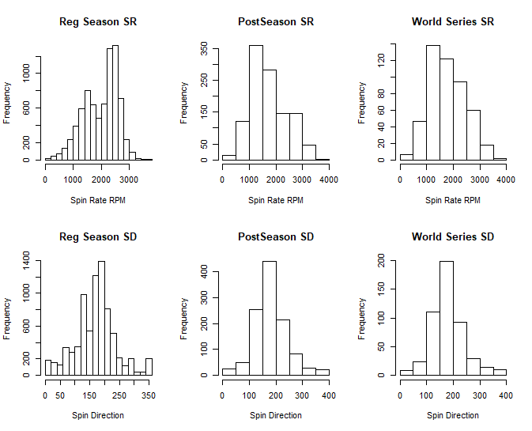

Looking at the Statcast Trackman data scraped off the MLB gameday directories (the source of data for all of our explorations), we’re merely taking a look at the spin rate and spin direction for all pitches thrown in 2017, split up by the regular season, post season (inclusive), and world series (exclusive). For the sake of cogency, we’re going to be re-using a lot of abbreviations: I apologize in advance for any confusion about using SD to indicate spin direction when it might pop up as the more naturally at ease among a statistical analysis term of standard deviation.

Again, we’re going to stay off the numbers for as much as we can, but the distribution seems markedly different in the postseason and world series vs the regular season.

Now, the type of pitch most affected by potential “slickness” would be the slider, as explained here <link>. So, repeating the seasonal splits, we stayed with the spin rate (a more statistically stable rate to look at than spin direction in small sample sizes <need sources>) and split up the graphs between sliders and non sliders.

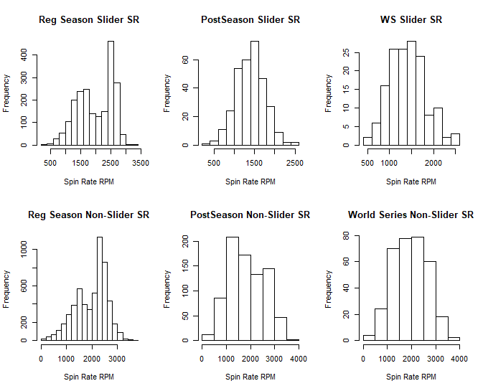

Again, jarring contrasts, and much more jarring in the Slider categories.

Here’s a numerical sampling of the results (I know, I know I said I’d stay off the numbers and I will but please bear with me here before I delve into individual metrics for our three guinea pigs. I promise I won’t go back on my word again…that is to say I will, but I’ll apologize for it like I just did there.)

|  |  |  |
| --- | --- | --- |
| ***Metric*** | ***Mean*** | ***SD*** |
| Spin Rate RS | 1989.218 | 604.563 |
| Spin Rate PS | 1725.752 | 679.718 |
| Spin Rate WS | 1778.519 | 668.531 |
| Spin Rate RS (SL) | 1988.945 | 574.264 |
| Spin Rate PS (SL) | 1401.731 | 357.303 |
| Spin Rate WS (SL) | 1417.806 | 409.897 |
| Spin Rate RS (non-SL) | 1989.319 | 615.397 |
| Spin Rate PS (non-SL) | 1851.737 | 731.829 |
| Spin Rate WS (non-SL) | 1941.109 | 698.709 |

A very casual overview: the spreads seem to get tighter with the Slider pitches specifically in the postseason; a Fisherian perspective on these numbers seems to paint a very staunchly significant difference. In fact, let’s just take a quick look at that and its sparring partner, Bayesian posteriors and priors, before I launch into the more individualized views I’ve been preaching.

<fill in stat sig stuff and Bayesian posteriors and priors>

Now, a quick look at all the visualizations we’ve seen, but this time for our slider-loving boys, Kershaw, Darvish, and Keuchel. Navigate through the six tabs to your heart’s delight and don’t blame me: I did warn you about the acronyms.